[Mohammad Hamza Ibrahim]  
[M00737296]

**PROJECT REPORT**

[Coursework 1 / Price Comparison Website]

1. Summary

In this project report I will include a detailed description of my website as well as all the website’s key functionality and the results of unit tests. I will also include an explanation of the web scraping, the RESTful web service and how the JavaScript displays the data within the project. A diagram showing final database design will be provided.

1. Description on the Price Comparison website

The website I created compares the prices of a range of iPhones from iPhone 6 to the latest iPhone 13. The web design is simple and easy, to allows quick and easy price comparison between several stores. Web scraping was used to grab information (from 6 sites) such as the iPhones name, description and price. this was then presented within the website I have created in a neatly format. The website also consists of a search bar, for specific searches, the user can search for an iPhone and those iPhones that are related to the user search will be presented along with the image and description. The iPhone are presented across many pages by the use of pagination. When an iPhone is selected, a page will appear with the iPhone’s details along with the prices of multiple iPhone deals (for the selected iPhone). The user will also have an option to be redirected to the site (which sells the iPhone). From then the user can get an in-depth detailed description on the iPhone helping them to decide to buy it or not. This website is not aimed to sell the iPhone in fact it is used to compare iPhones from several different sites allowing the user to get the best possible deal.

The reason I chose to create a phone price comparison website is not only because phones are being used more every year but also it prevents the user to open multiple tabs to compare different prices of phones. Therefore, my website allows a much more efficient way for online shopping.

1. Website’s key functionality

In this section I will compare the requirements given in the mark scheme with the functionalities I have created. This includes functionalities within threads, maven, hibernate and spring.

1. 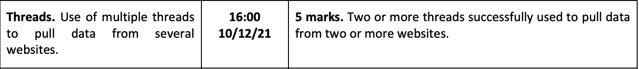Threads

Within the project I have scrapped data from 6 different sites:-

* <https://www.ur.co.uk/>
* <https://www.backmarket.co.uk/>
* <https://www.theioutlet.com/>
* <https://www.mobilephone4u.co.uk/>
* <https://www.alloallo.com/>
* <https://www.mac4sale.co.uk/>

Within my java application each scraper has its own class (thread). These threads consist of data being scrapped from third party websites and with the help of hibernate, the data scrapped can be injected into the database.

1. 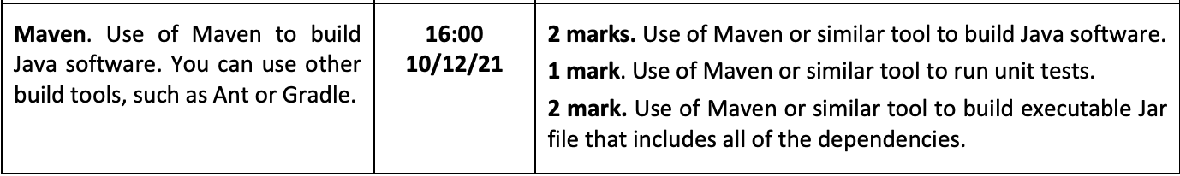Maven

By running **mvn package** in the command line, this will obtain all of the dependencies needed to run the scraping programme. This will also run Java unit tests and create an executable Jar file with all of the dependencies included. See the illustration below:

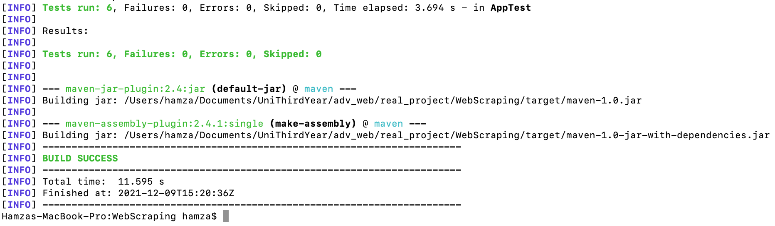**Running mvn package**

This image shows that when running **mvn package** it results in all 6 unit tests passing. It also creates 2 jar file with one including the dependencies. The **maven-1.0-jar-with-dependencies.jar** can then be run by inputting the command **java -jar ./target/maven-1.0-jar-with-dependencies.jar**. This allows the java (main) to run. Which consists of adding the scrapped data into the database.

1. Spring

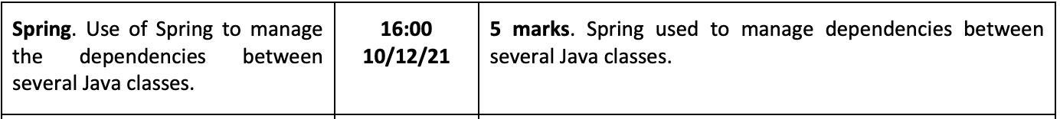

I used Spring "beans" in the Java application within “AppConfig.java” class file to manage dependencies between multiple Java classes. Here are several examples:

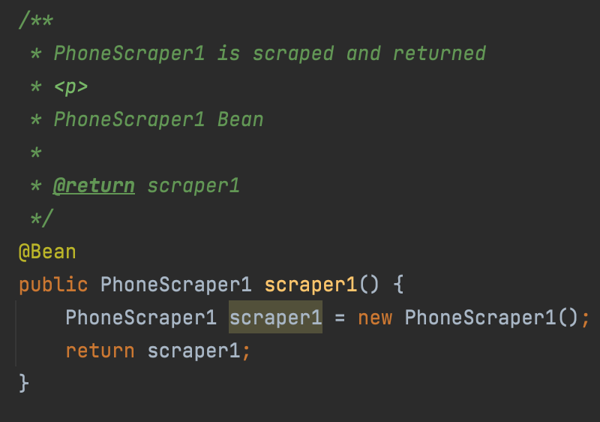

“PhoneScraper1” is a function which scrapes data from a website (<https://www.backmarket.co.uk/>) and adds it to the database using hibernate.

Below image shows the implementation.

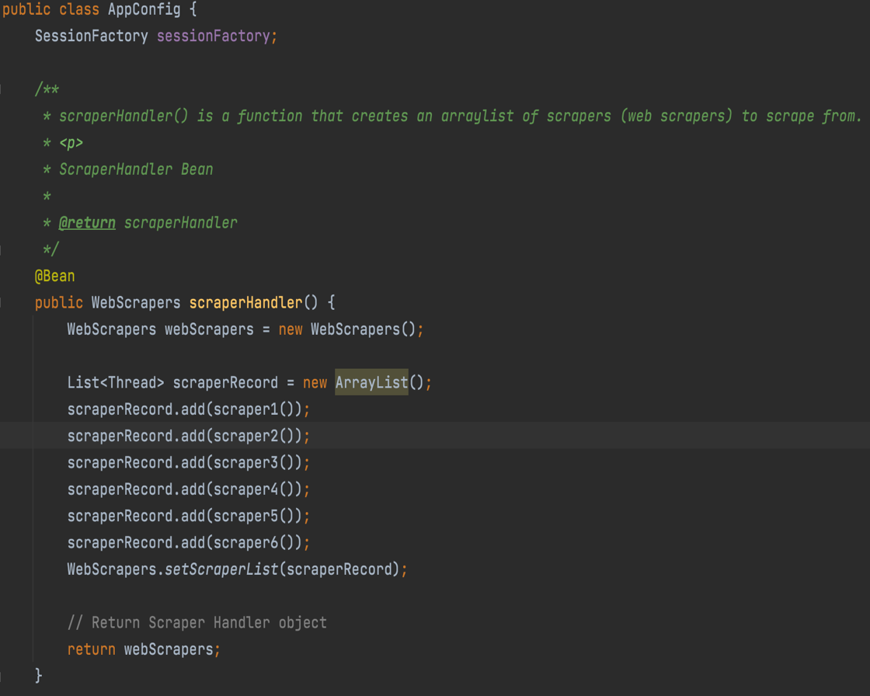

Initialized “WebScrapers” object

Create list of web scrapers.

Add scraper object to the list.

add it to the “WebScrapers”

return the “webScraper” object

Bean is declared in both image since it has the @Bean annotation. When JavaConfig encounters such a method, it will execute that method and register the return value as a bean within a BeanFactory. By default, the bean name will be the same as the method name.

1. Hibernate

Using Hibernate annotations and foreign key mapping, I stored data in a MySQL localhost database using Java Hibernate. When using Hibernate annotations, Hibernate.cfg.xml file is needed. This file will have mappings defined for each class.

**Hibernate.cfg.xml:-**

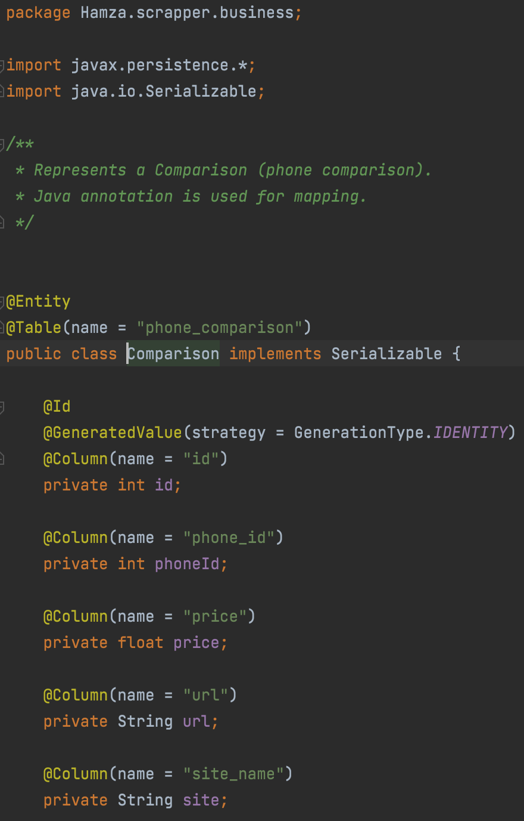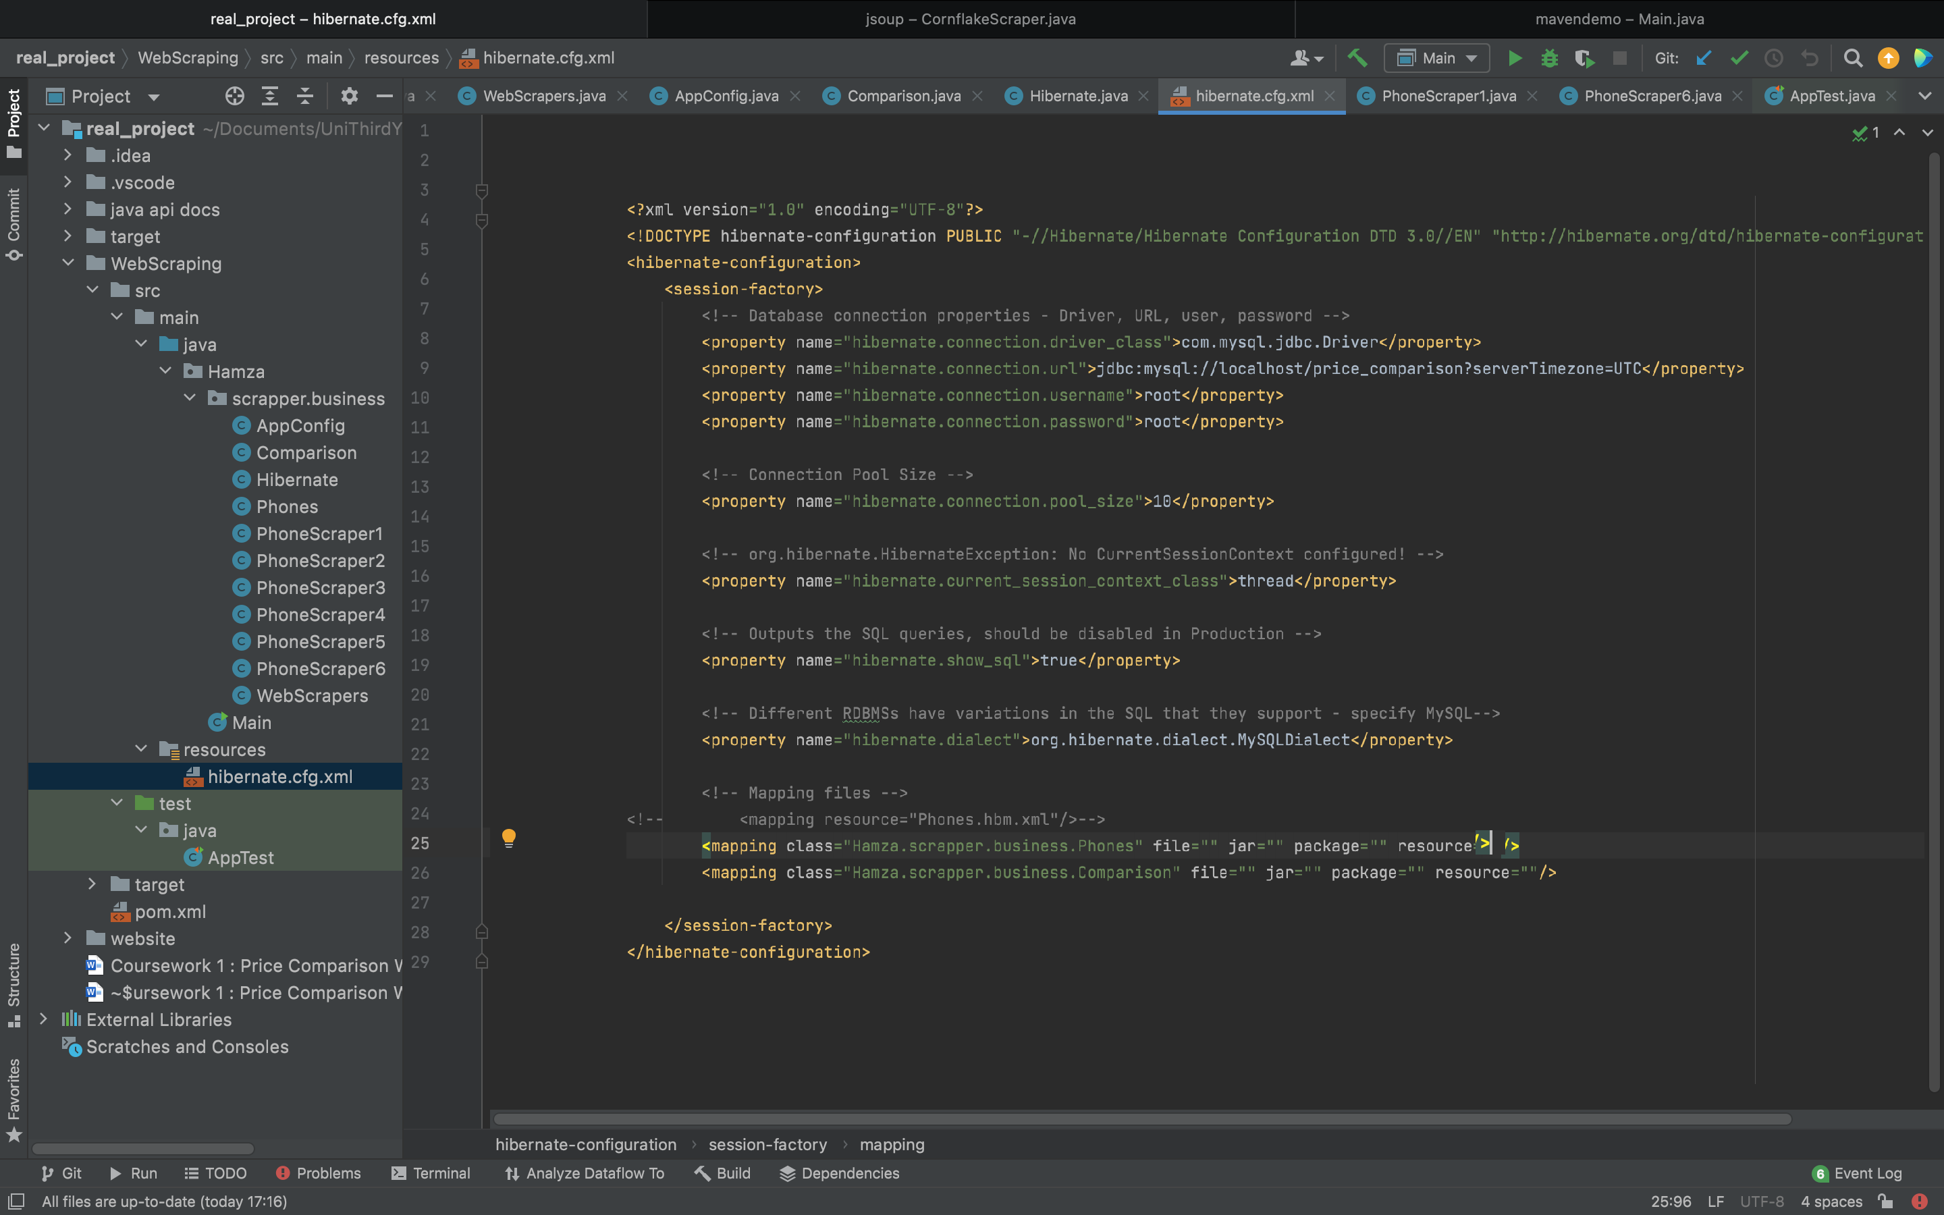

**Hibernate.cfg.xml** file contains the mapping of the comparison class

Within my scraper classes (e.g. PhoneScraper1) it demonstrates the storage of data from, scraper class to MySQL database.

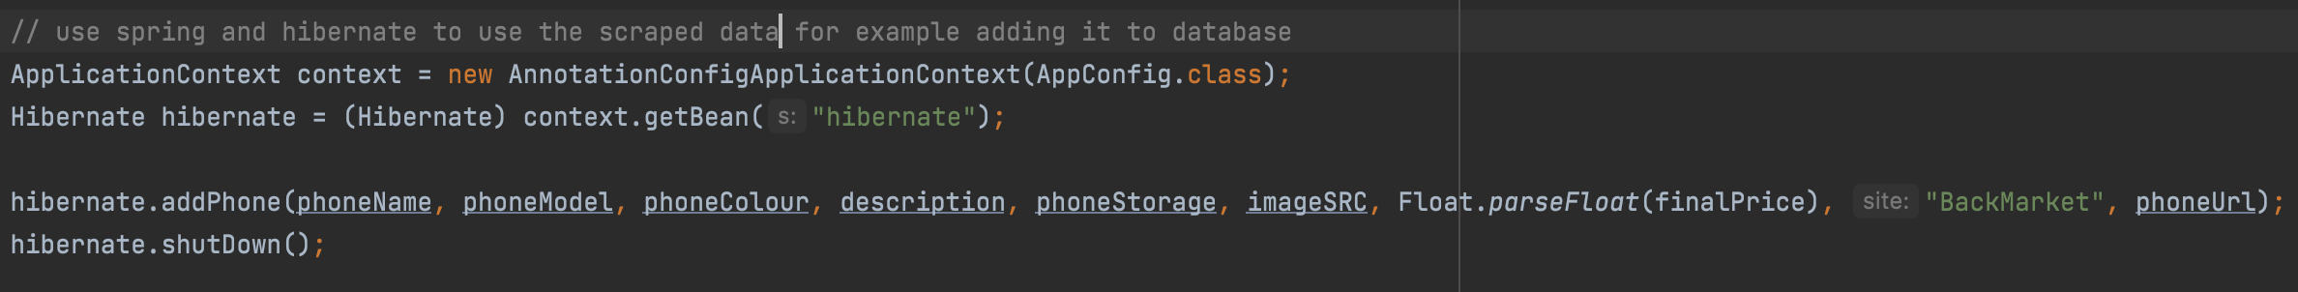Example:-

Figure 1

Figure 1 is presented in all 6 of the scraper class towards the end of the function. “AppConfig.class” (spring) is used to call “hibernate”. In order to add the phone to the database (“addPhone()” function described below).

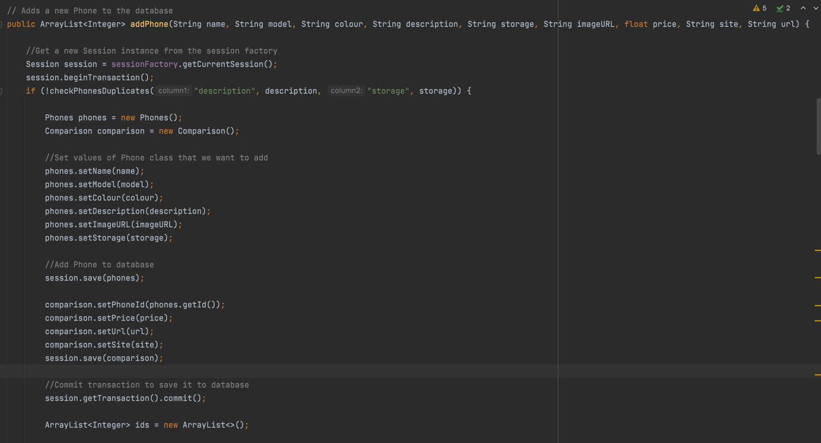The variables within “addPhone()” function is all the scraped data form the sites.



Figure 2

“addPhone()” function from figure 2 first gets new session from session factory. Then it checks for duplicates (checkPhoneDuplicates() function). If there is no duplicates it creates each class object that represents the database. Then it sets elements, that have been scraped, in the objects. Object is then saved. Finally, it commits the transaction and closes the session.

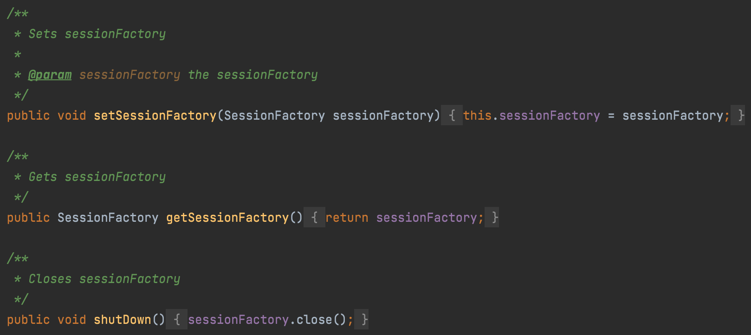

Figure 3

All functions in Figure 3 is within the hibernate class.

1. 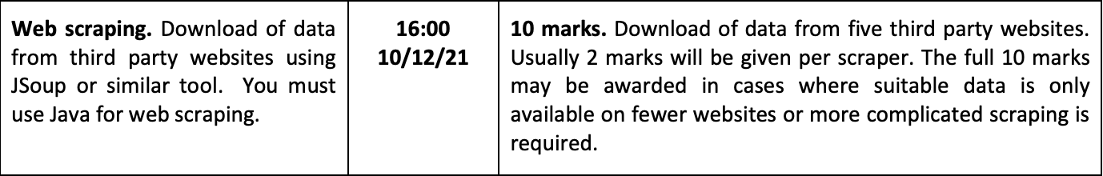Web scraping

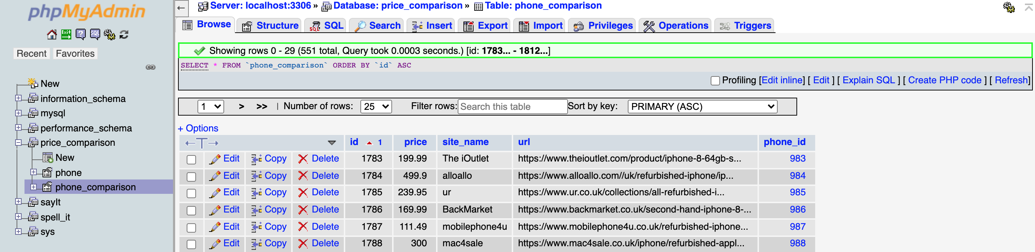Within my java application it shows that I have scraped and downloaded from 6 different third party website using JSoup. This can be presented within my database.

Figure 4

Figure 4 shows data scraped from 6 different sites this is demonstrated under the columns “site_name” and “url”.

1. 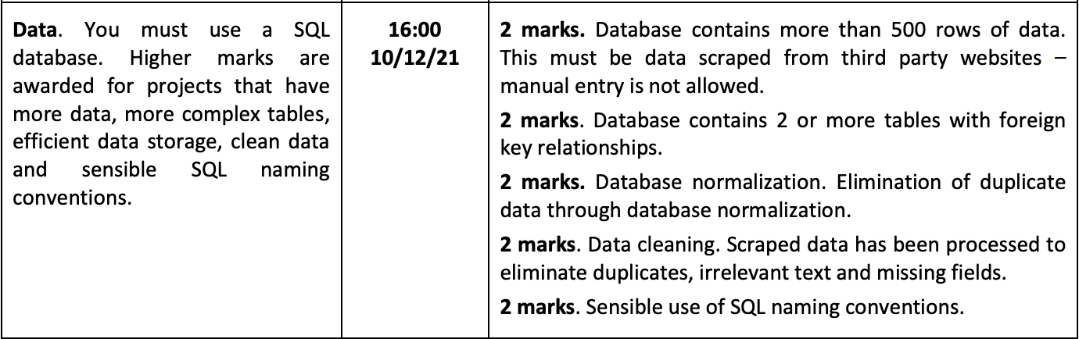Data

Within MySQL database the query **SELECT COUNT(*) FROM tablename** can be used to count the rows of data within a table. I have ran this code and it shows a gathering of more then 500 rows of data.

Count 262 for table “phone”

Count 551 for table “phone_comparison”

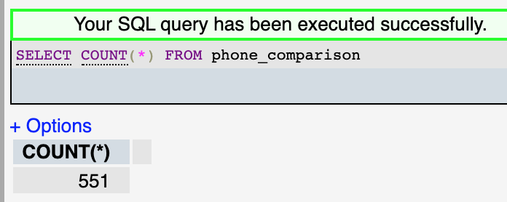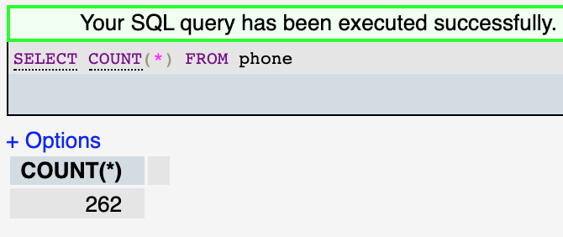

MySQL database also has foreign key relationship.

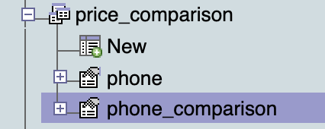

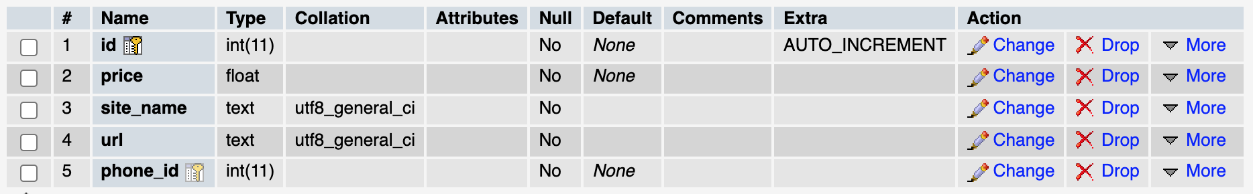

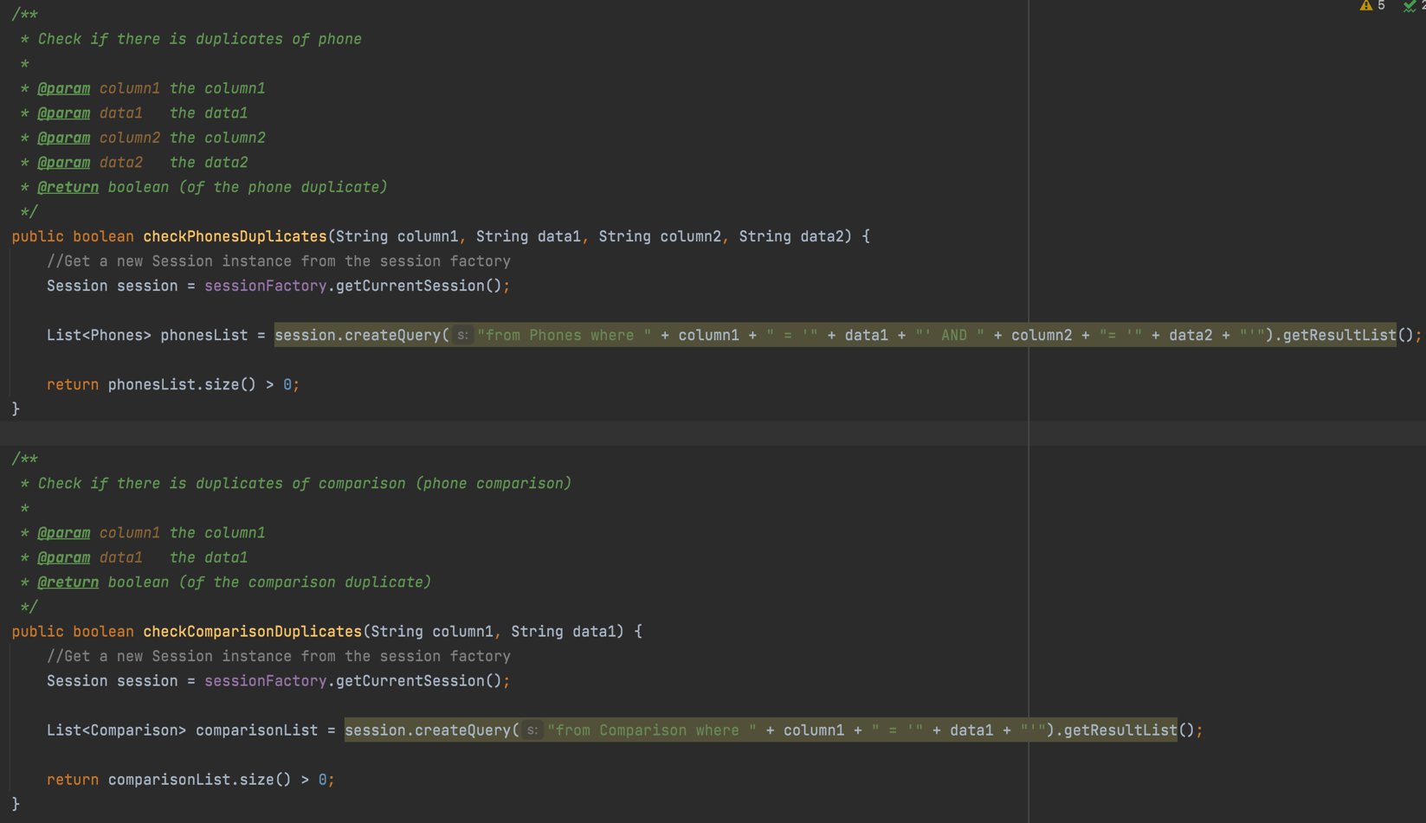

Figure 5

The scraped data has been processed to eliminate duplicates by the 2 functions in figure 5. They both compare columns within the database with the data scraped. If there is a duplicate the list increases therefore it will return true.

Irrelevant text and missing fields also are eliminated within the phone scraper classes.

1. 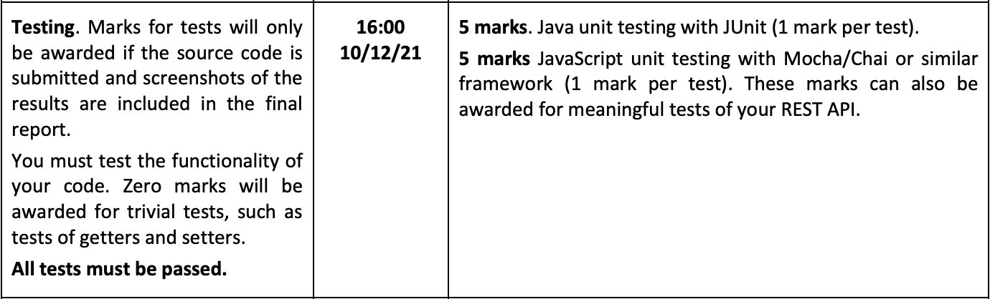Testing

The project I have created have both unit and mocha/chai testing’s. The test are shown below:-

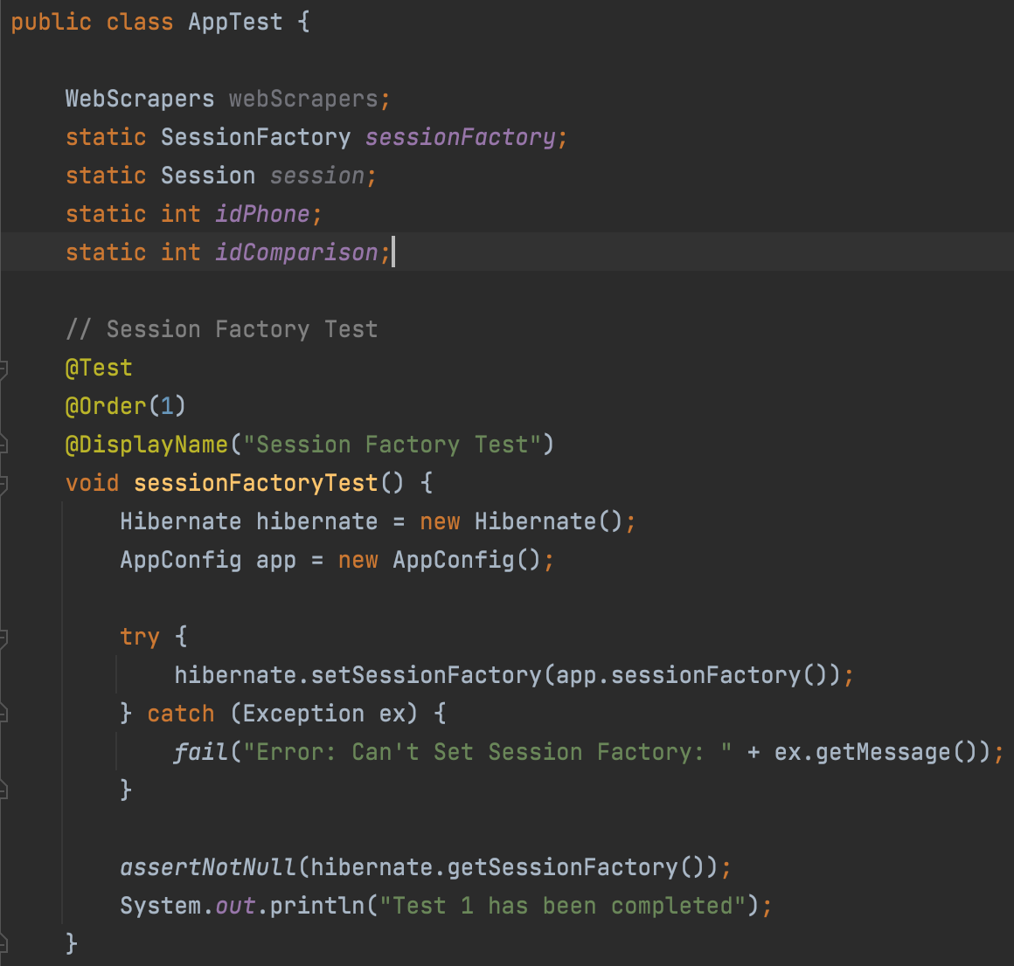**Unit tests:-**

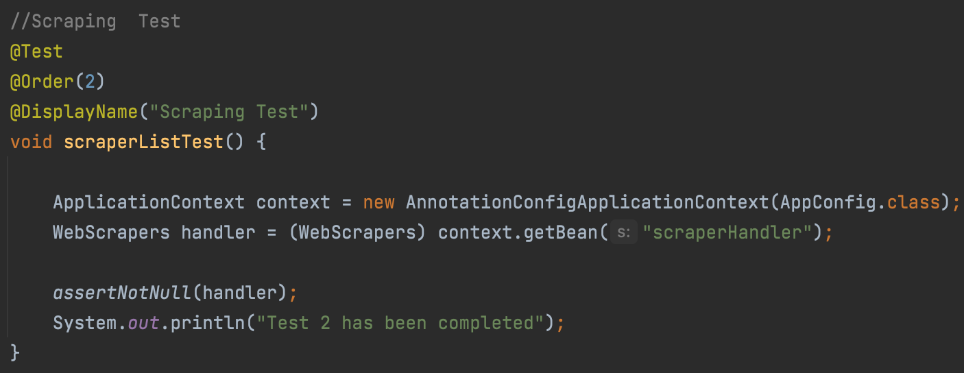

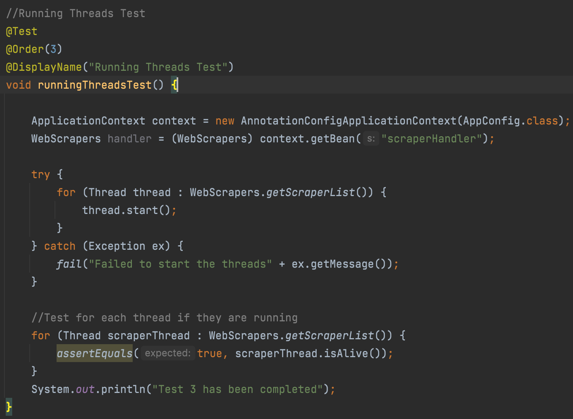

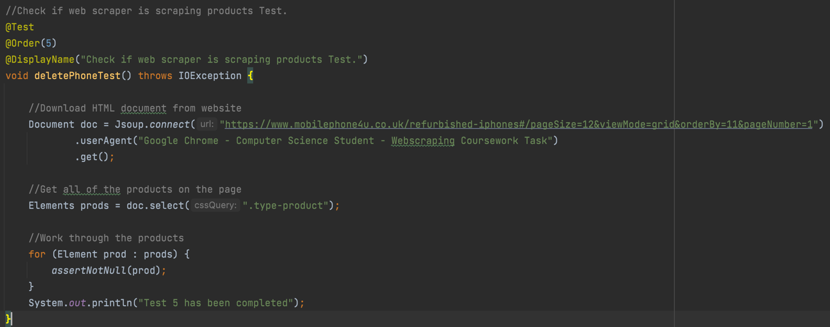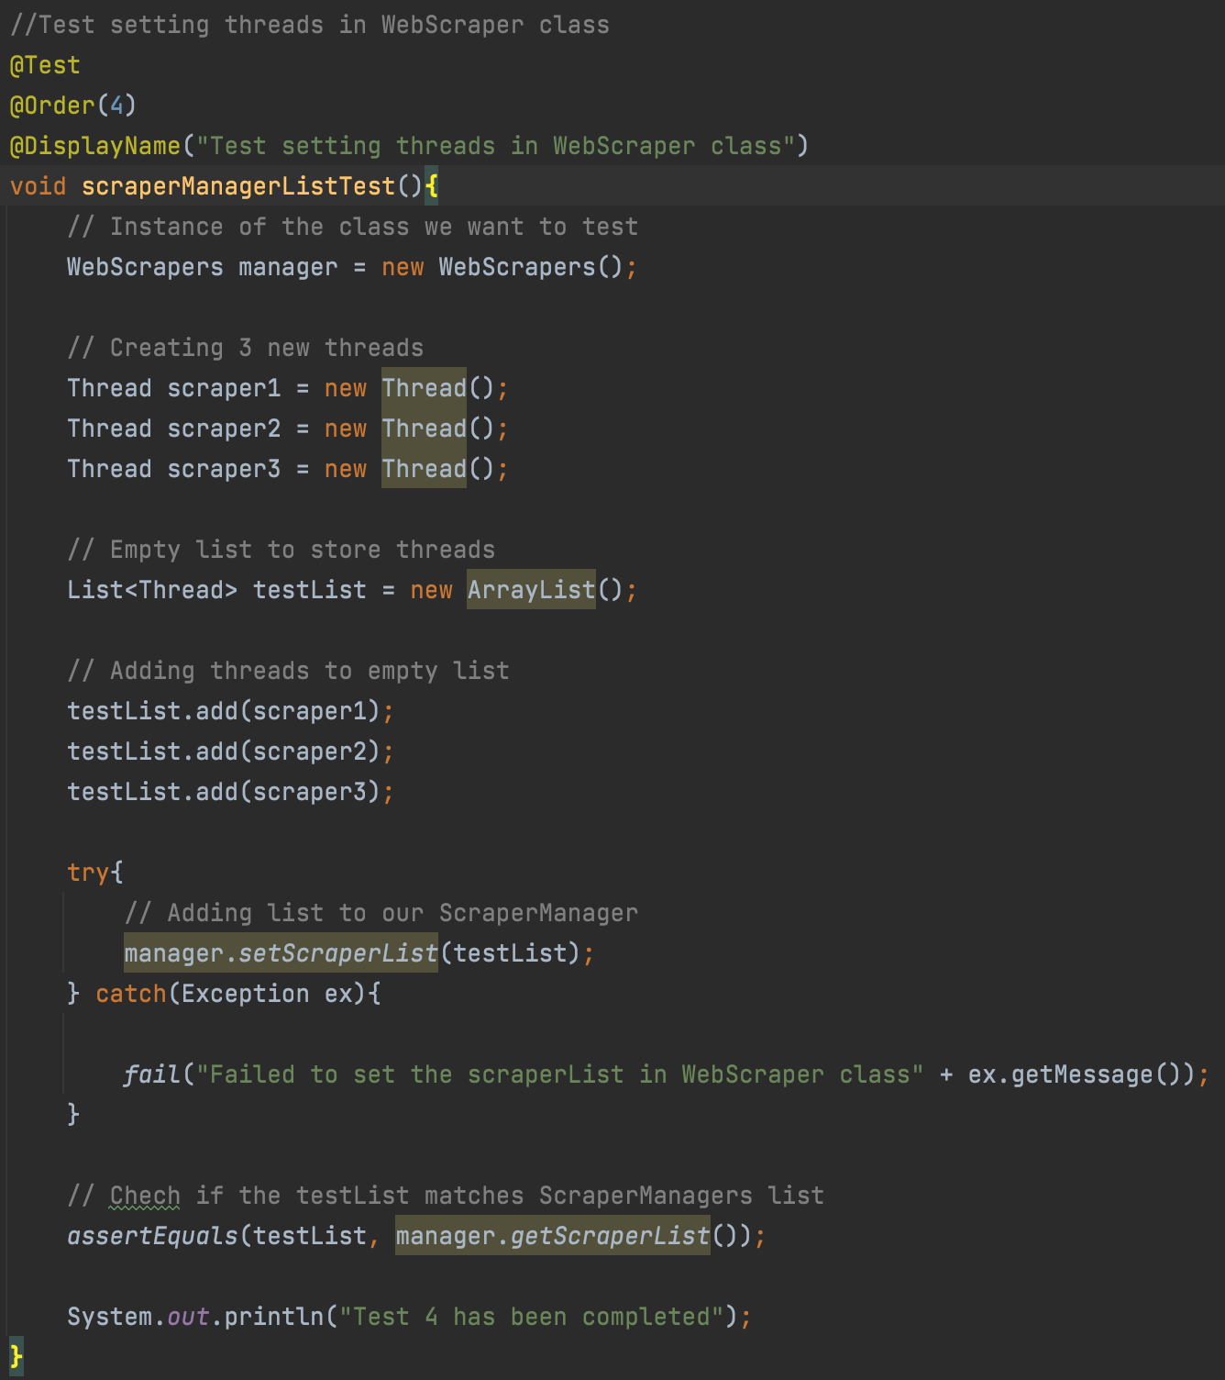

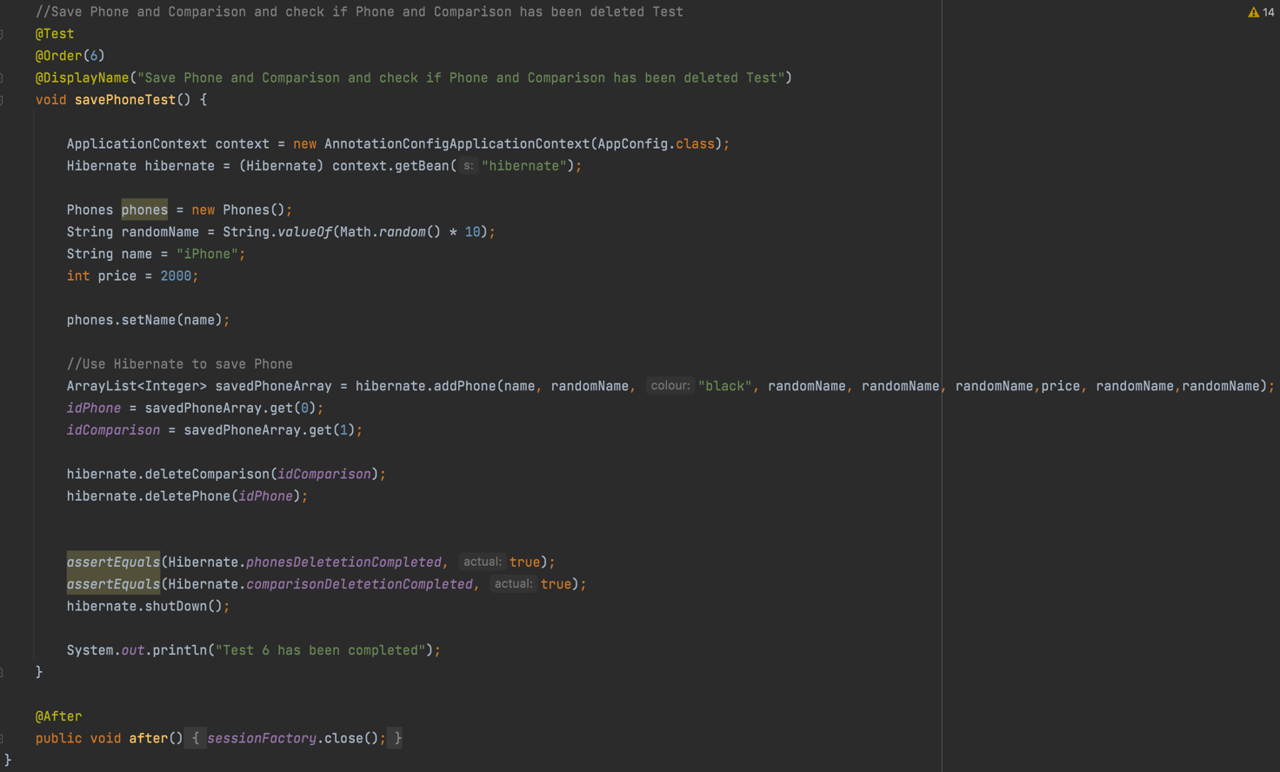

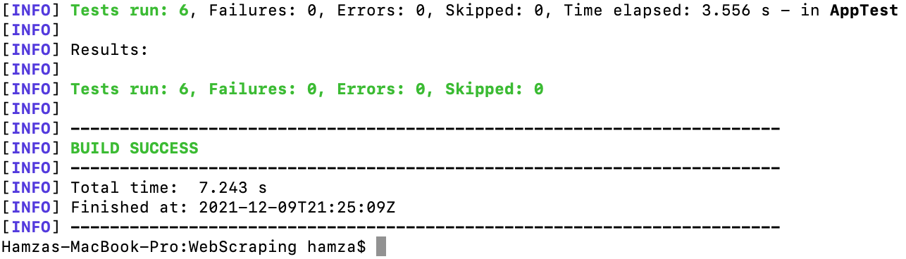

From the images of unit test we can conclude that 6 tests have been created and all 6 tests have passed. (A little description of the test is commented above every test.).

**Unit testing Mocha/Chai:-**

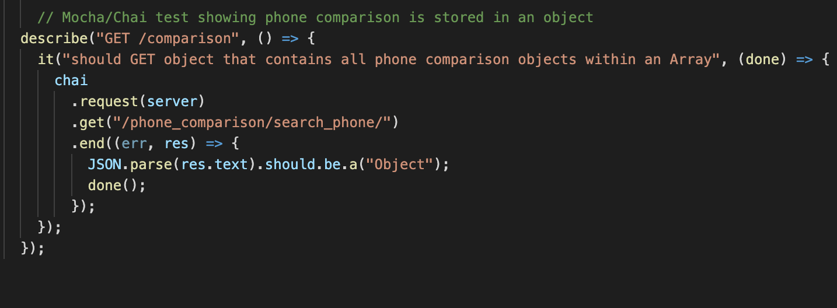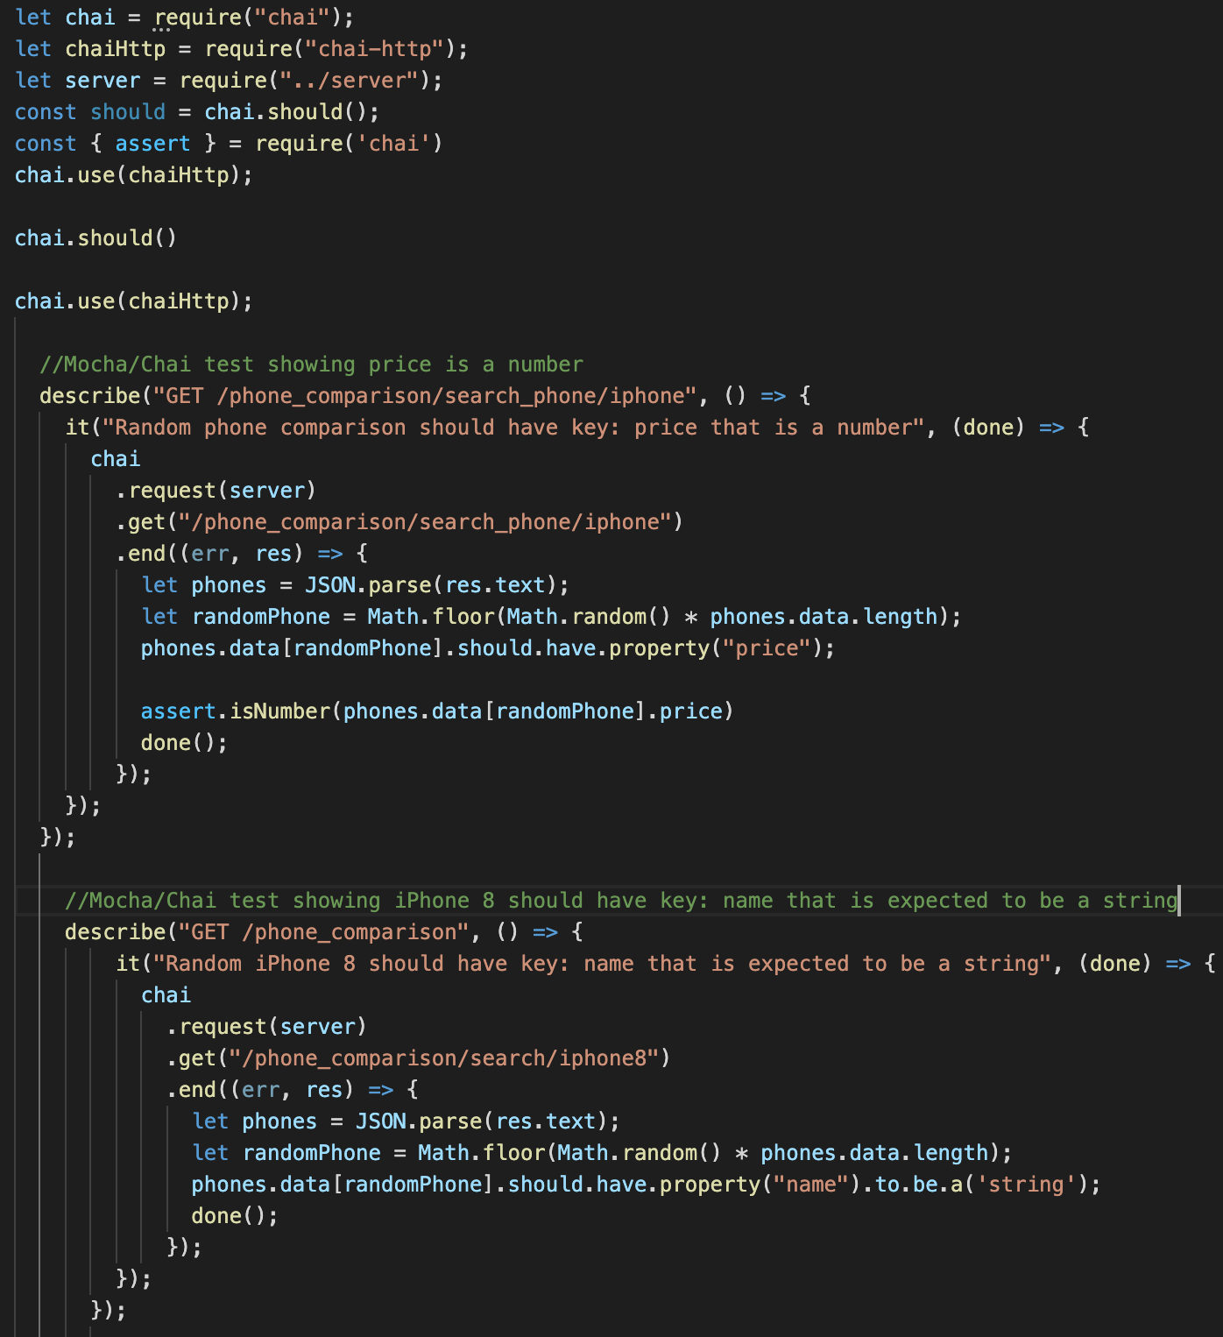

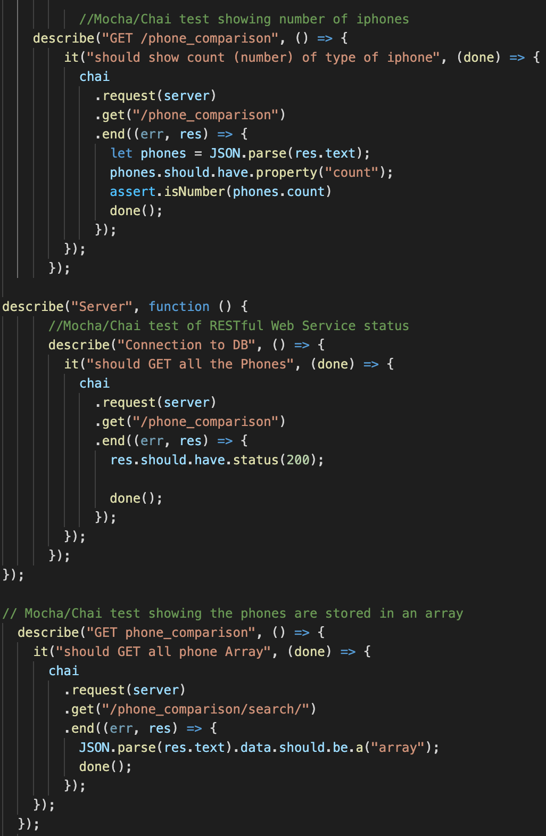

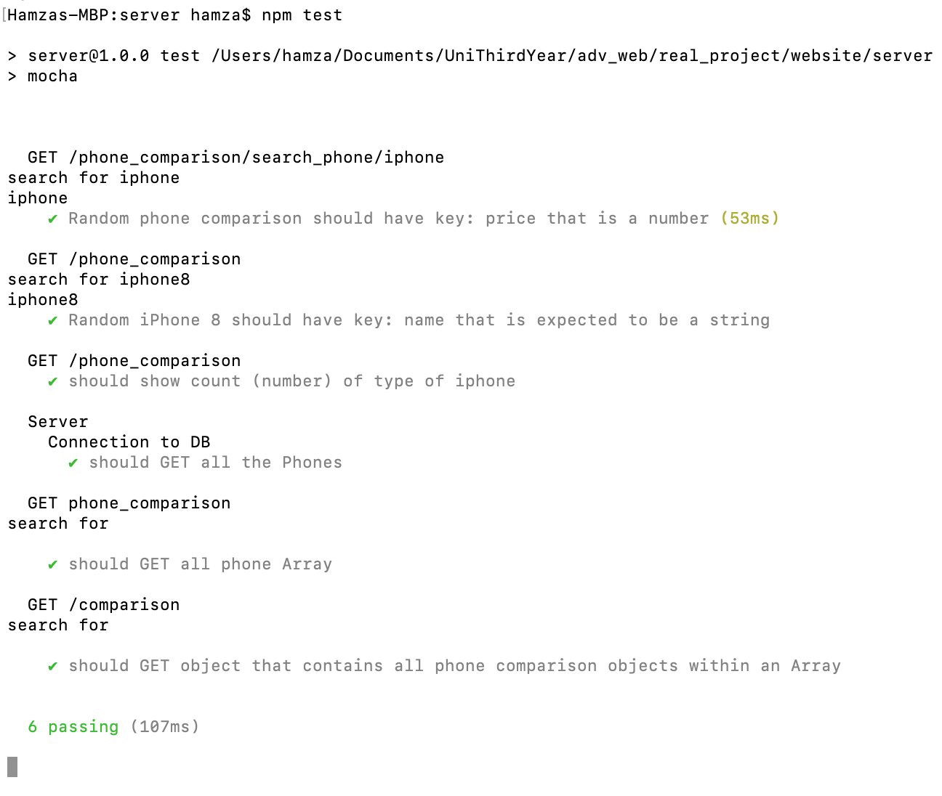

From the images of unit test from Mocha/Chai we can conclude that 6 tests have been created and all 6 tests have passed. (A little description of the test is commented above every test.).

1. REST API

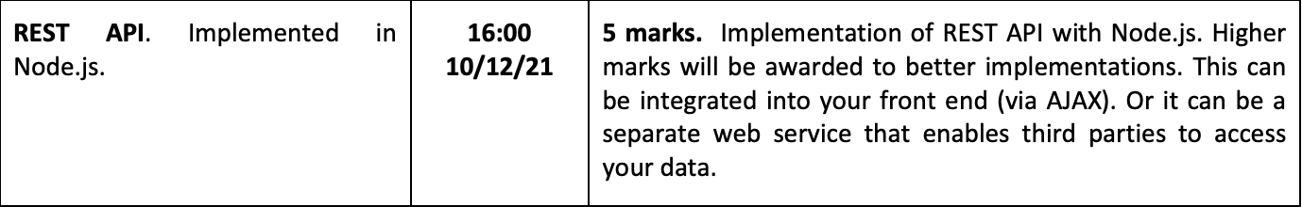

REST API was implemented using Node.js. “**server.js”** filein **“server”** folder was used for the backend. To run the node server simply run “node server” within the project in the command line.

**server.js:**

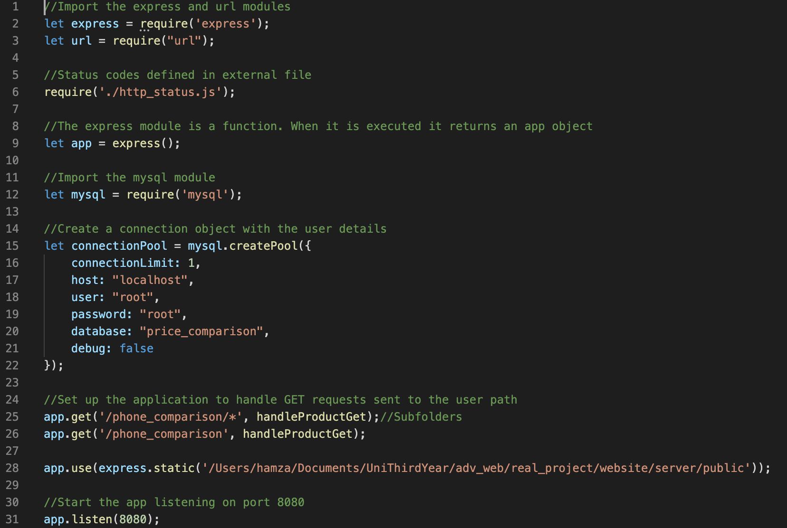

**http_status.js:**

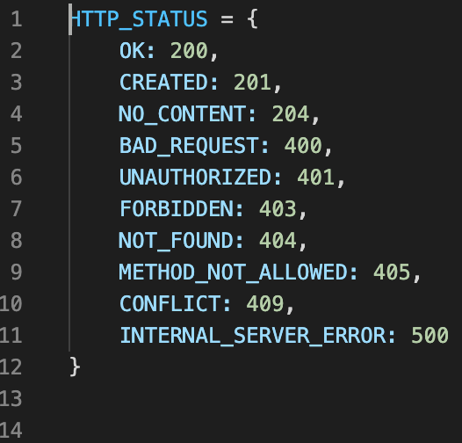

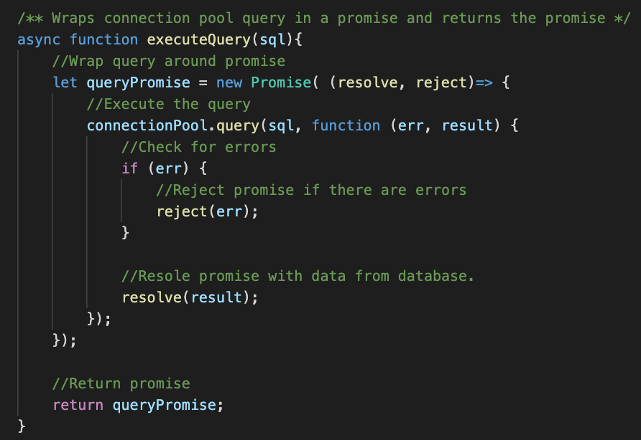

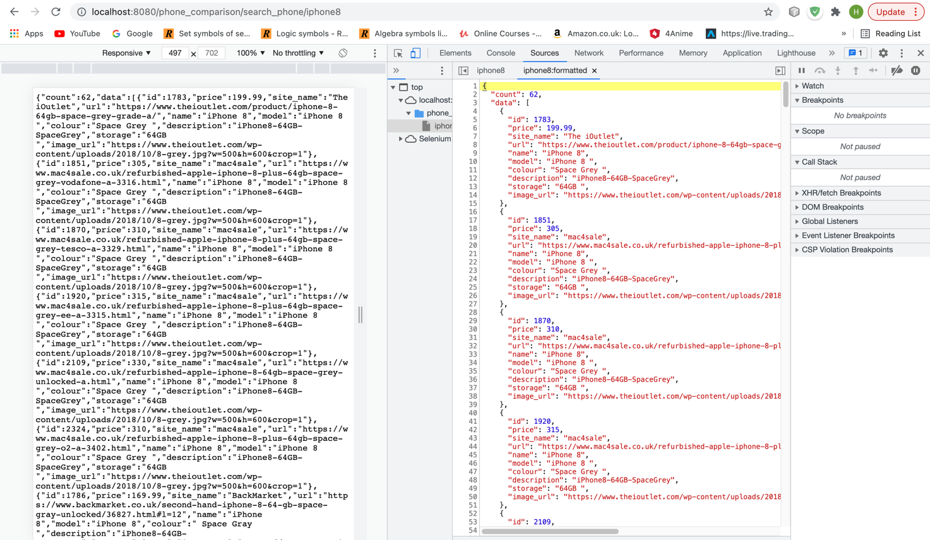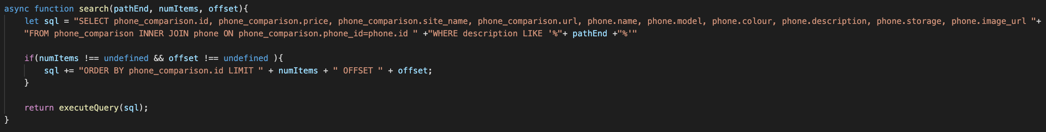

Figure 6

Figure 7

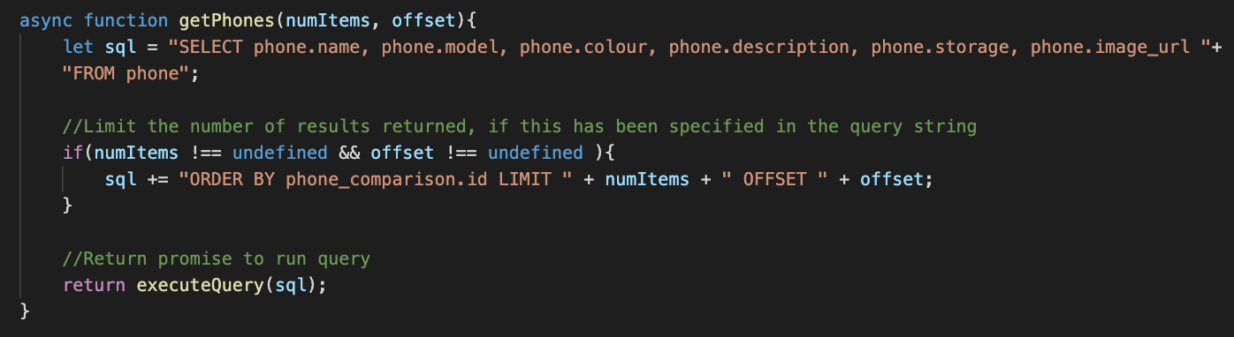Figure 6 gets all data from “phone_comparison” for a specific phone depending on the path-end and how the path-end relates to the “description”. For example in figure 7 the path-end is ”iphone8”. The function then checks if the path-end matches the “description” of any phones within the “phone_comparison” table. It then presents those phones on the screen. Therefore figure 7 only presents phones that include iPhone 8 within the description. If the path-end is “search_phone” it returns all phones within phone_comparison table.

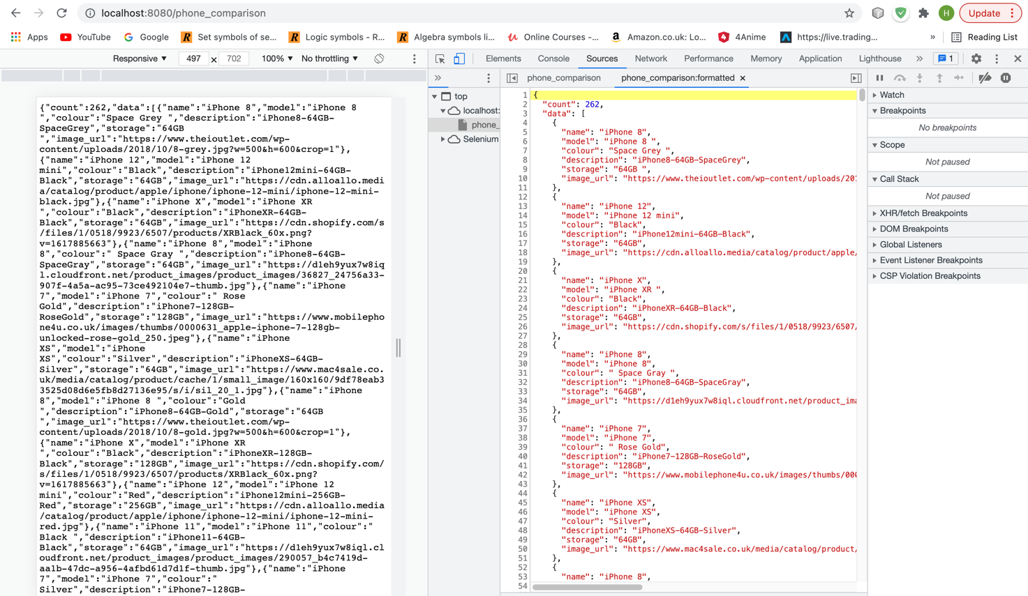

Figure 8

Figure 9

Figure 8 gets all data from “phone” table and is presented. This can be seen in figure 9.

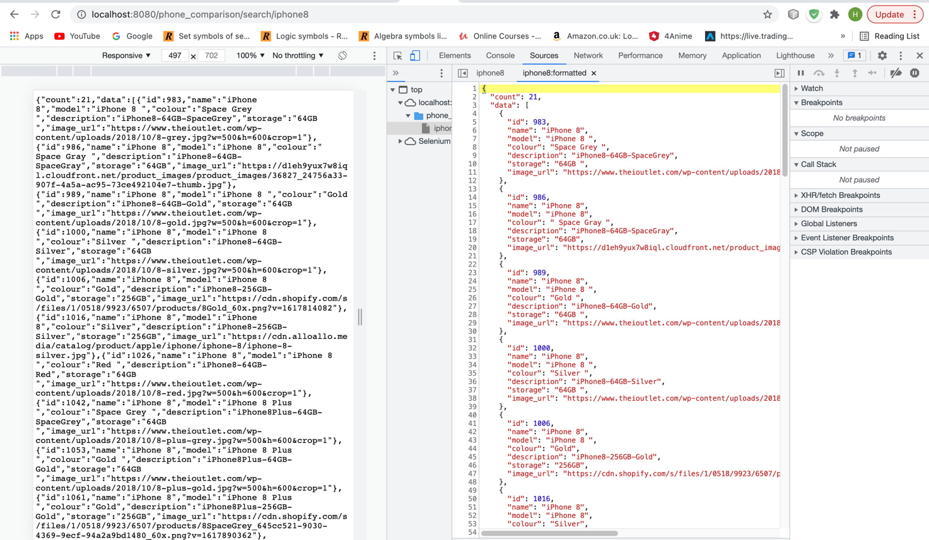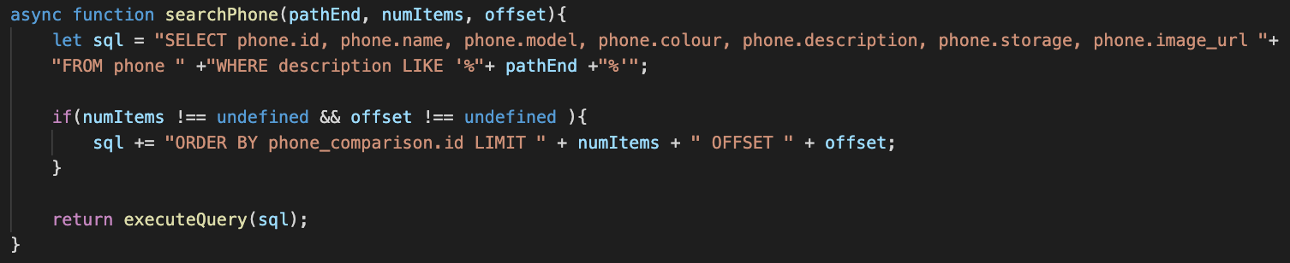

Figure 10

Figure 11

Figure 10 gets all data from “phone” table for a specific phone depending on the path-end and how the path-end relates to the “description”. For example in figure 11 the path-end is ”iphone8”. The function then checks if the path-end matches the “description” of any phones within the “phone” table. It then presents those phones. Therefore figure 11 only presents phones that include iphone8 within the description. If the path-end is “search” it returns all phones within “phone” table.

1. 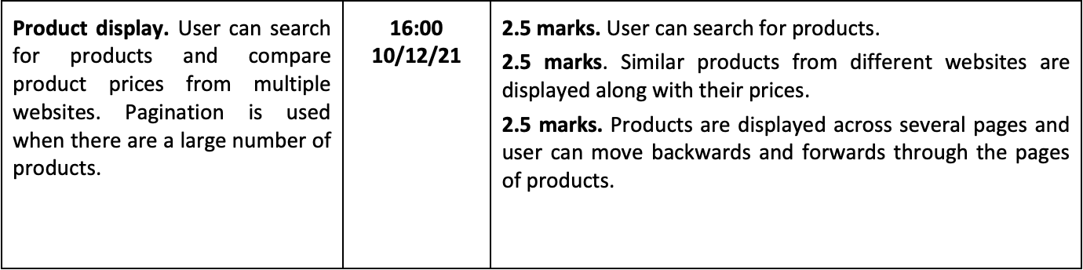Product display

The front end of this project was built using Vue. Since Vue made it easier to present large list of phone data onto the webpage. Axios was used for fetching data from server. This was more used on the functions, based on events in the webpage, for example the buttons to “search” and “compare” phones.

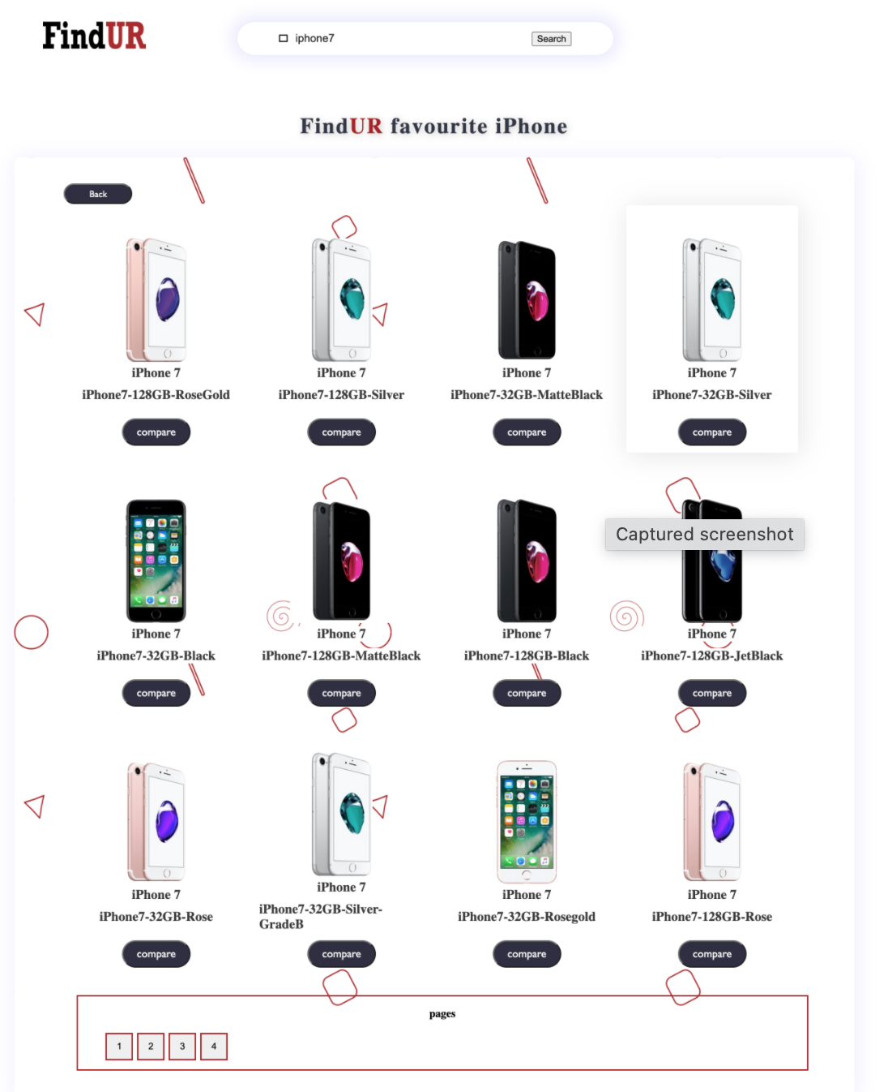Within the website the user can search for products:-

As you can see when the user searched for “iPhone 7” only iPhone 7 are presented on the webpage. Also towards the bottom of the screen pagination is implemented. Pagination was created with just JavaScript. It presents 12 products from the arrays of phones for every page.

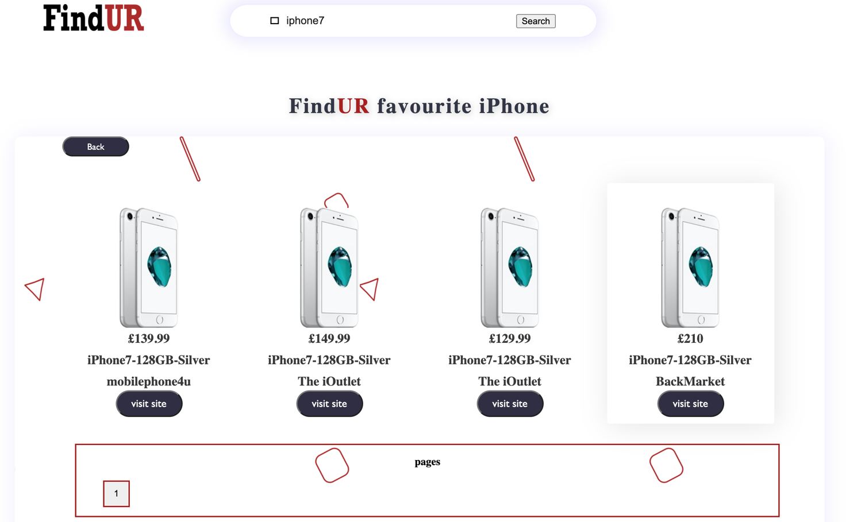The user can press the “compare” button to compare the prices of different sites:-

By clicking on the “visit site” button the web page redirects to the site where the product is sold at. This was completed by imbedding the site URL into the buttons.

1. Database design

